EUROSYMPOSIUM’2017 REPORT
On 22nd September’2017, the Xth EuroSymposium was held at Department of Business Informatics, Faculty of Management, University of Gdansk, Poland. Like every year, the co-organizers of this event were:
- Polish Chapter of Association for Information Systems (AIS) – PLAIS,
- Special Interest Group on Systems Analysis and Design of Association for Information Systems – AIS SIGSAND,
- Department of Business Informatics at University of Gdansk.
EuroSymposium'2017 was held under the auspices of the Committee on Informatics of the Polish Academy of Sciences and European Research Center for Information Systems in Muenster, Germany – ERCIS. The Xth EuroSymposium had a special attribute regarding the Jubilee of the 50th Anniversary of Business Informatics at University of Gdansk.
The theme of EuroSymposium'2017 was: “Information Systems – Research, Development, Applications, Education”. There were three topic sessions during EuroSymposium:
- Data Analytics,
- Web Based Information Systems,
- Information Systems Development.
Keynote speech entitled "The Bayeux Tapestry of Information Systems" was presented by Professor Frank Land (AIS LEO Award and Fellowship of AIS Winner) and Professor Chrisanthi Avgerou from the London School of Economics.
During the event, the accepted submissions were presented by representatives of IS academic centers from 10 countries – the Czech Republic, Canada, Ecuador, Germany, Portugal, Serbia, Spain, United Kingdom, USA and Poland. Most of the papers were submitted by the foreign authors. The acceptance rate for EuroSymposium'2017 was 22%, i.e. only every fifth paper was accepted. It means that Gdansk EuroSymposium has achieved the global level of statistics and standards of quality as well as extensive international interest in the event.
The accepted papers have been published in the prestigious Springer Science publishing series Lecture Notes in Business Information Processing – LNBIP. It is abstracted/indexed in DBLP, EI and Scopus; LNBIP volumes are also submitted for the inclusion in ISI Proceedings. During EuroSymposium'2017, the Poster Session was organized – for the first time in the event history. Proceedings of the Extended Abstracts of EuroSymposium'2017 Poster Session, were published by the Department of Business Informatics as a part of the series of Research Reports on Business Informatics, printed in English since 1991. So far, over 100 issues have been published, by domestic and foreign authors.
PLAIS/SIGSAND EuroSymposia will be held annually at the end of September in Gdansk, Poland.

The Participants of EuroSymposium'2017
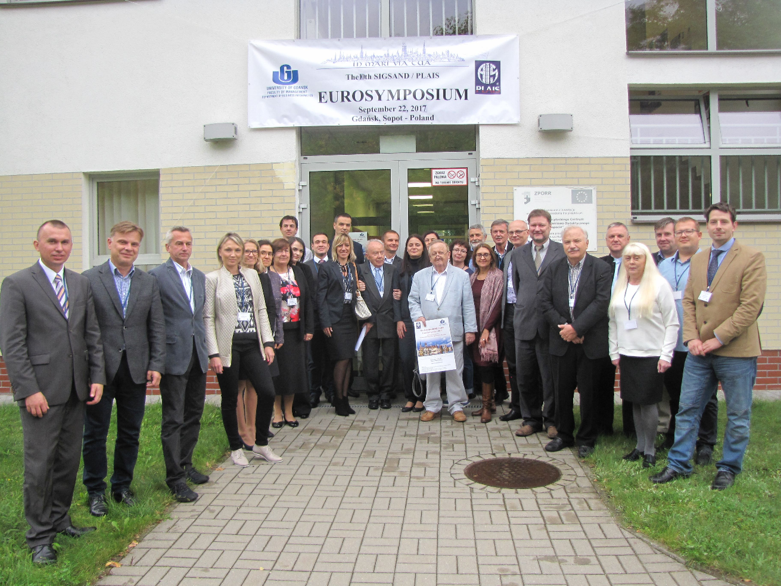
Inauguration of EuroSymposium'2017 - Professor Miroslaw Szreder (left), Dean of the Faculty of Management at University of Gdansk and Professor Stanislaw Wrycza, General Chair of EuroSymposia
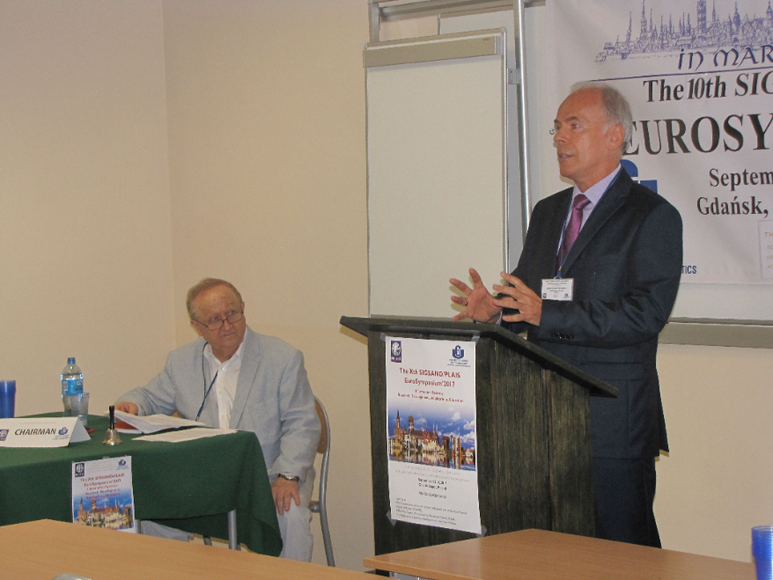
Keynote Speech as videoconference -
Professor Frank Land and Professor Chrisanthi Avgerou
from the London School of Economics
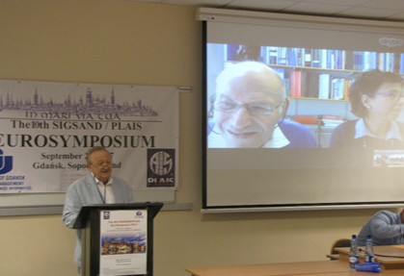
Discussion during the plenary session – Professor Mariia Rizun, Professor Vera Meister and Professor Stanislaw Wrycza
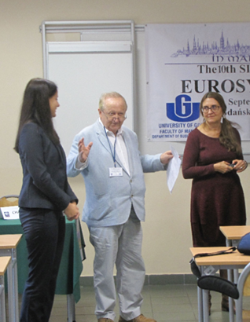
Plenary session – Professor Vaclav Repa from the University of Economics in Prague and Professor Stanislaw Wrycza, University of Gdansk
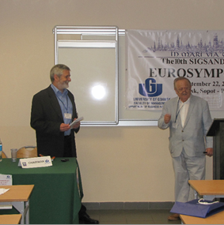
Poster session of EuroSymposium’2017
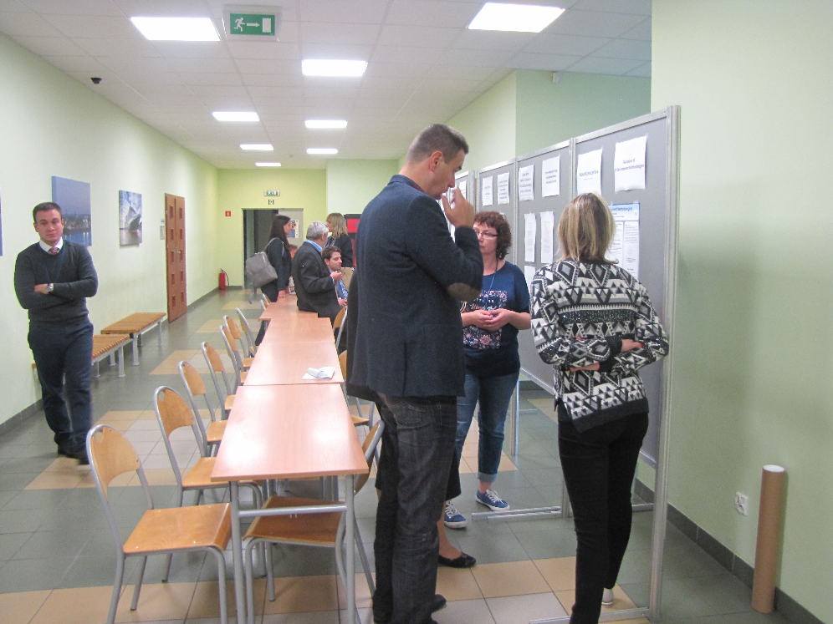

The participants of EuroSymposium’2017 during the plenary session
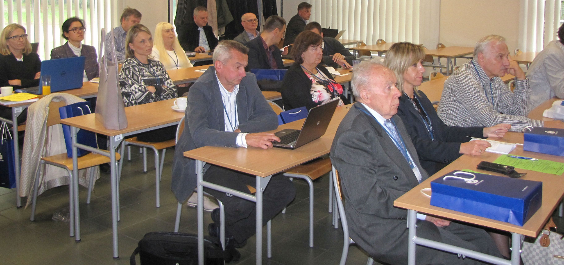
Proceedings of EuroSymposium’2017 published by Springer Science in the series LNBIP – Lecture Notes in Business Information Processing | Proceeding of the Extended Abstracts of the EuroSymposium’2017 Poster Session, published by  Department of Business Informatics  of University of Gdansk in its series  Research Reports on Business Informatics
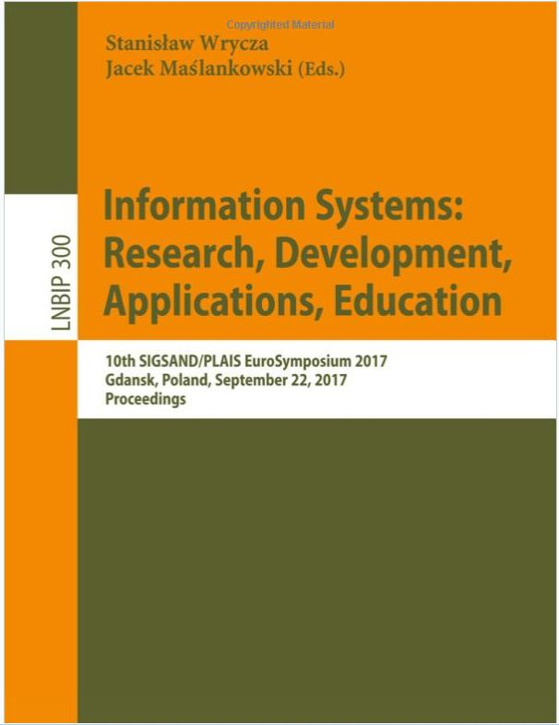 | 